S: referral from urologist under impression of prostate Ca, AJCC stage IIIB
C.C.: urinary frequency, nocturia & urgency for a long time
P.I.: A 72-year-old male has suffered from LUTs S/Sx for months. Then, he went to the GU OPD for help, where the DRE showed enlarged prostate & stony hard over the both lobes prostate, bilateral capsules and seminal vesicles. He had TRUS biopsy and TRUS-guided biopsy revealed adenocarcinoma. Gleason Grade Group 4
ROS: low back pain & left hip pain for a period

O: PS: 0
P.E.: tenderness over the left hip.
DRE: stony hard over the both lobes prostate, bilateral capsules and suspicious seminal vesicles involvement.
PSA: 47.11 ng/ml
Images:
- MRI: see disc
- Bone scan: see disc

Questions :
- Please describe the image findings in the provided staging MRI, CT.
- Do you have any therapeutic recommendations before radiotherapy( if RT is a part of your treatment recommendations )
- Stage the patient by the 2018 8TH AJCC staging.
- What the treatment do you recommend for this patient ?
- If radiotherapy is part of your treatment recommendations :
- Please describe & reason your planned GTV, CTV and PTV.
- Outline CTV on the provided non-contrast CT images.
- What is/are the prescribed radiotherapy dose(s) ?
- How do you evaluate your treatment planning ?
- Name the possible radiation side effects.

- Please describe the image findings in the provided staging MRI, CT.
Pelvis MRI:
Imaging findings :
1. Tumor location / Size
Visible tumor (v) Right lobe (v) Left lobe
2. Tumor invasion
Prostate
(v) Involves both lobes
(v) Extracapsular extension
(v) Seminal vesicle invasion
3. A heterogeneity intensity of the left acetabulum (ischium) is seen, favoring bone metastases

IMPRESSION:
1.Imaging stage for prostate carcinoma (According to American
Joint Committee on Cancer, AJCC 8th edition) ; T:3b N:0 M:1b

Bone scan:
Marked increased uptake intensity of the left acetabulum (ischium) us seen, favoring bone metastasis.

- Do you have any therapeutic recommendations before radiotherapy( if RT is a part of your treatment recommendations )
Bone scan
- Stage the patient by the 2018 8TH AJCC staging.
TNM: c T3b N0 M1b, stage IVB, Grade group 4
- What treatment do you recommend for this patient?
- 根據國建署資料，男性病人平均餘命查表得知，此病人為72歲，預期存活年限超過五年。根據最新版之NCCN，不適合選擇observation或只用ADT.
- According to the last version of the NCCN guideline for prostate cancer, high-volume disease is differentiated from low-volume disease by visceral metastases and/or 4 or more bone metastases, with at least one metastasis beyond the pelvis vertebral column. Patients with low-volume disease have less certain benefit from early treatment with docetaxel combined with ADT. In contrast, ADT and EBRT to the primary tumor for low-volume M1 is recommended. This recommendation is based on the STAMPEDE phase 3 randomized trial, which randomized 2,061 men to standard systemic therapy with or without radiotherapy to the primary. The prespecified low-volume subset had a significant improvement in both failure-free survival and overall survival.

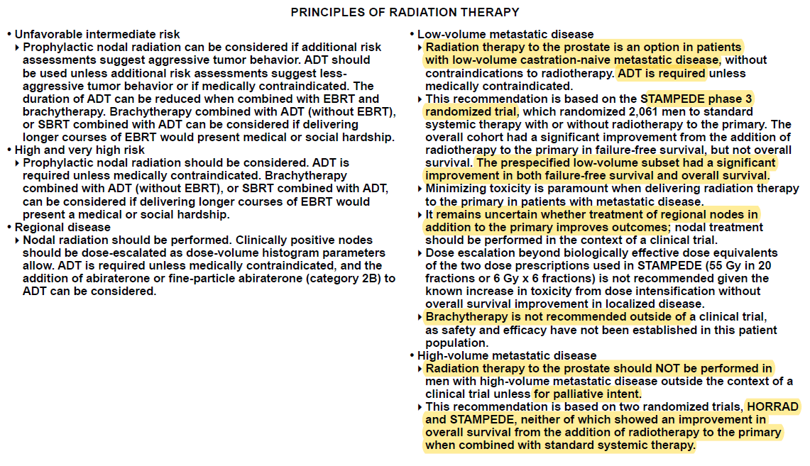
- According to the last version of the NCCN guideline for prostate cancer, EBRT to sites of metastases can be considered if metastases are in weight-bearing bones or if the patient is symptomatic.
- 根據以上所述，我會建議使用 ADT + RT to prostate +/- palliative RT to the left acetabulum (ischium). 若病人不願意接受RT，根據NCCN，也可以選擇ADT + abirateron

5. If radiotherapy is part of your treatment recommendations:
(1) Please describe & reason your planned GTV, CTV and PTV.
According to the the last version of NCCN guidelines of prostate-principle of RT:
In lower volume M1 disease: It remains uncertain whether treatment of regional nodes in addition to the primary improves outcomes; nodal treatment should be performed in the context of a clinical trial.
Prostate only RT: Radiotherapy is given with the patient supine and with a full bladder and an empty rectum. IMRT with daily IGRT will be arranged.
According to Target Volume Delineation for Conformal and Intensity-Modulated Radiation Therapy by Nancy Y. Lee et al and NCCN guidelines of prostate-principle of RT:
■ CTV：prostate +/- seminal vesicle
■ PTV：CTV + 0.6 – 1.0 cm

Palliative RT to left acetabulum (ischium)
■ GTV：left acetabulum (ischium)
■ PTV：left acetabulum (ischium) with 1cm margin

(2) Outline CTV on the provided non-contrast CT image.
(3) What is/are the radiotherapy dose(s)? (重要評分依據)
According to the NCCN guidelines:
Prostate only RT: (55 Gy in 20 fractions, QD or 6 Gy x 6 fractions, QW)
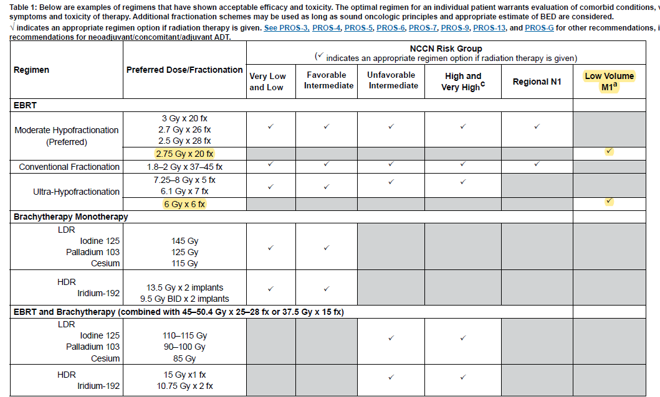
Palliative RT to left acetabulum (ischium):40 Gy / 20 fractions

(4) How do you evaluate your treatment planning?
Dose prescription
■ 55 Gy isodose surface emcompasses 100% CTV
■ 55 Gy isodose surface emcompasses 95 (97)% PTV
■ 100% PTV received ≧ 95% prescribed dose
■ No more than 20% of PTV receive ≧ 110% of the prescribed dose
■ No more than 1% of PTV receive ≦ 93% of the prescribed dose
■ No more than 1 c.c. outside the PTV receive ≧ 110% of the prescribed
Dose limitation (EQD2 dose)
■ Bladder V75 < 25%, V40 < 50%
■ Rectum V75 < 15%, V40 < 40%
■ Femoral head Dmax ≦ 50 Gy
■ Small bowel: no more than 150cc > 45 Gy
■ Penile bulb:Dmean<52.5 Gy
(5) Name the possible radiation side effects.
Acute toxicity: urgency, frequency, nocturia, dysuria, diarrhea, rectal irritation, pain, bleeding, fatigue
Subacute and late toxicity: urinary stricture, rectal bleeding, decreased volume of ejaculate, absolute excess risk of secondary bladder or rectal cancer risk is <0.5% after RT.

